IPL Assignment

1. **Most wins in IPL**

Create pivot table>> drag **winner** to rows>> drag **count of winner** to values

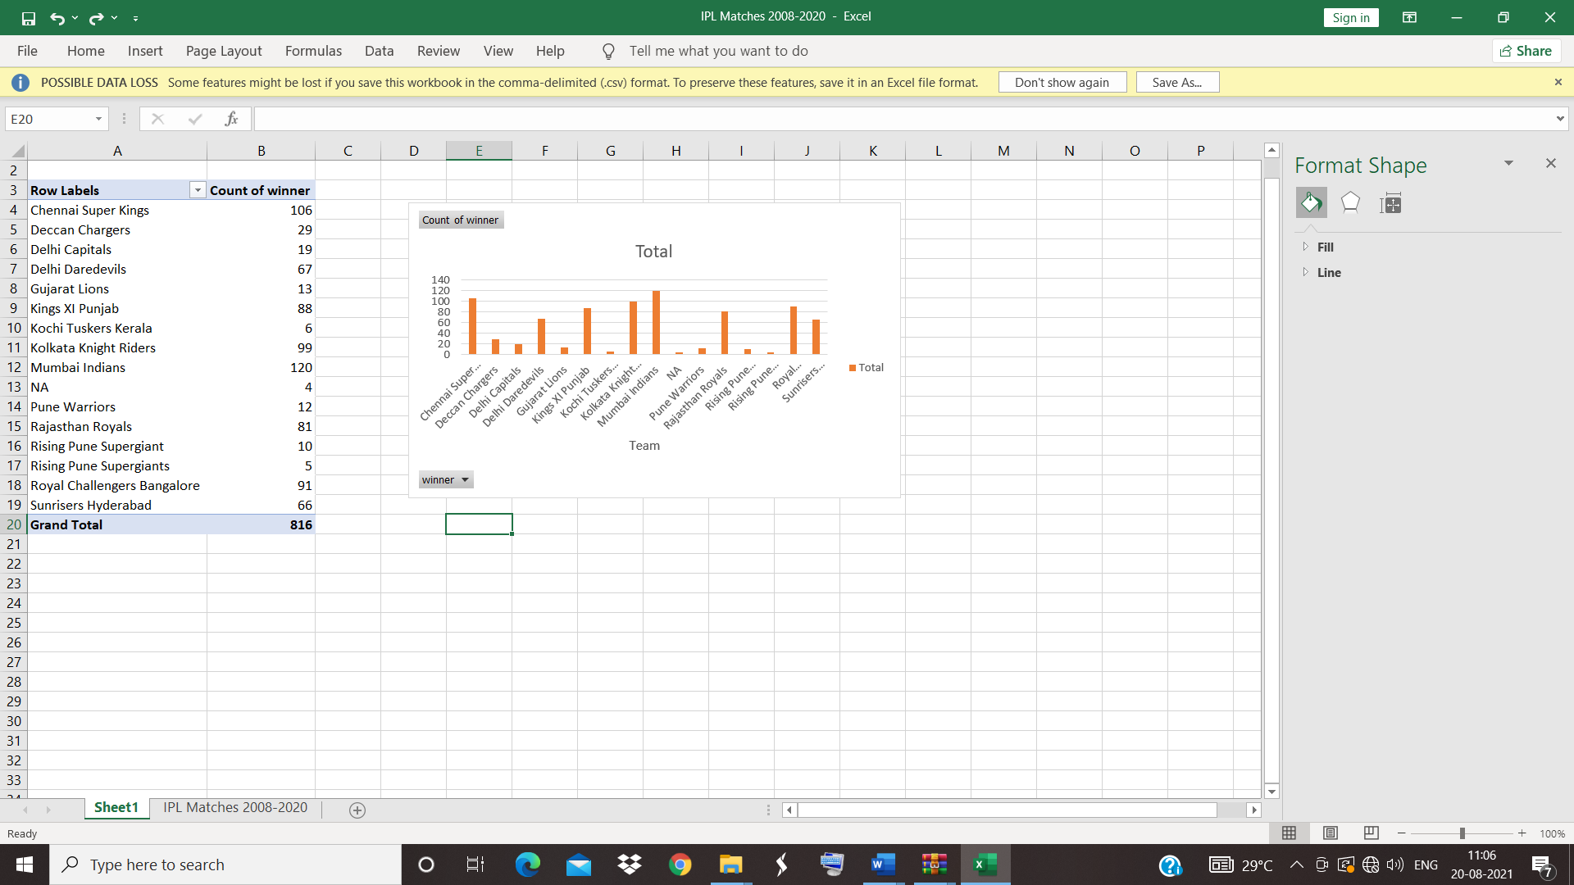

Pivot table and pivot chart created

**Mumbai Indians** wins most in IPL and counts 120, followed by Chennai super kings with a difference of 14 counts.

Chennai superkings, deccan chargers ,delhi capitals, delhi daredevils, Gujarat lions,king XI Punjab ,kochi tuskers kerala, kolakata knight riders, Mumbai Indians, pune warriors, rajastan royals, rising pune supergaints, sunrise Hyderabad are the winning teams of the tournament.

**2)TOSS DECISION**

Create pivot table>> drag **winner** to rows>> drag **count of toss decision** to values>> drag **toss decision**  to columns

Analyze>> insert slicer>> toss selection is selected

Pivot table and pivot chart created

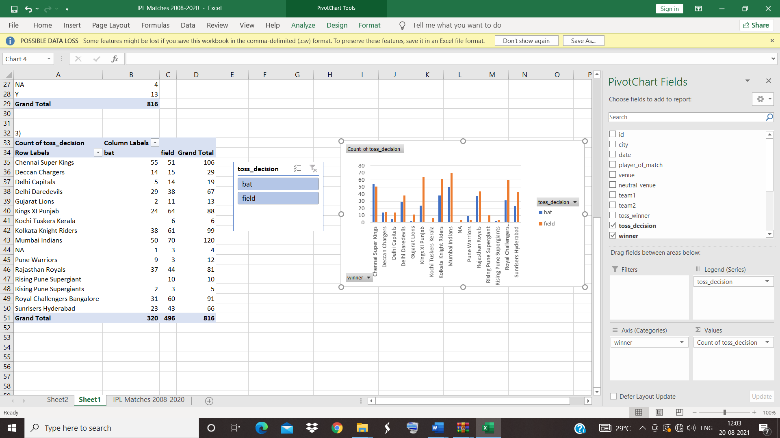

Inference

With the batting decision ,after toss Chennai super kings wins 55 matches and with field decision Mumbai Indians wins 70 matches.

>> **Mumbai Indians has more fielding capability than batting.**

**3)Famous stadium**

Create pivot table>> drag **venue** to rows>> drag **count of venue** to values

Pivot table and pivot chart created

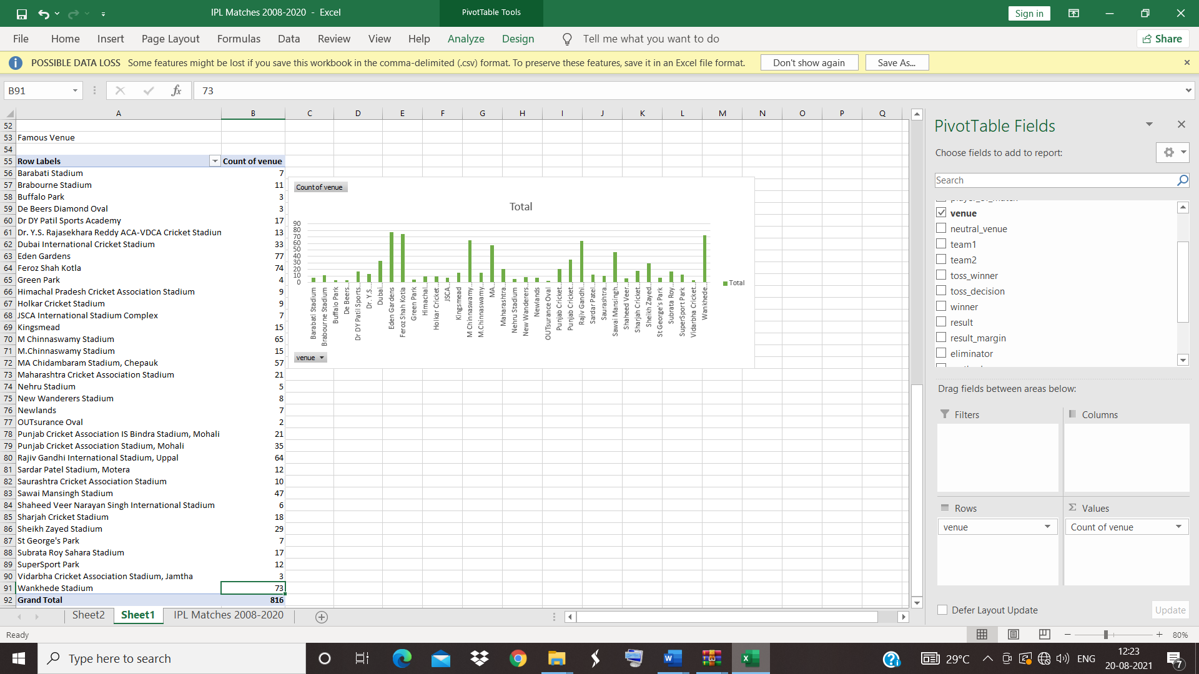

Inference

Eden gardens is the famous as 77 matches are played on there ,followed by Wankhede stadium with 73 matches

**4.**[**How many runs were scored in each season?**](https://www.kaggle.com/saiswaroop018/ipl-data-analysis-and-visualization-project#2)

* Open file ‘ IPL ball- by -ball 2008 -2020’>> create pivot table>> drag **ID** in to rows and drag **Sum of total_runs** and **Sum of extra_runs**  in to values .Total runs is created by summing total and extra runs.

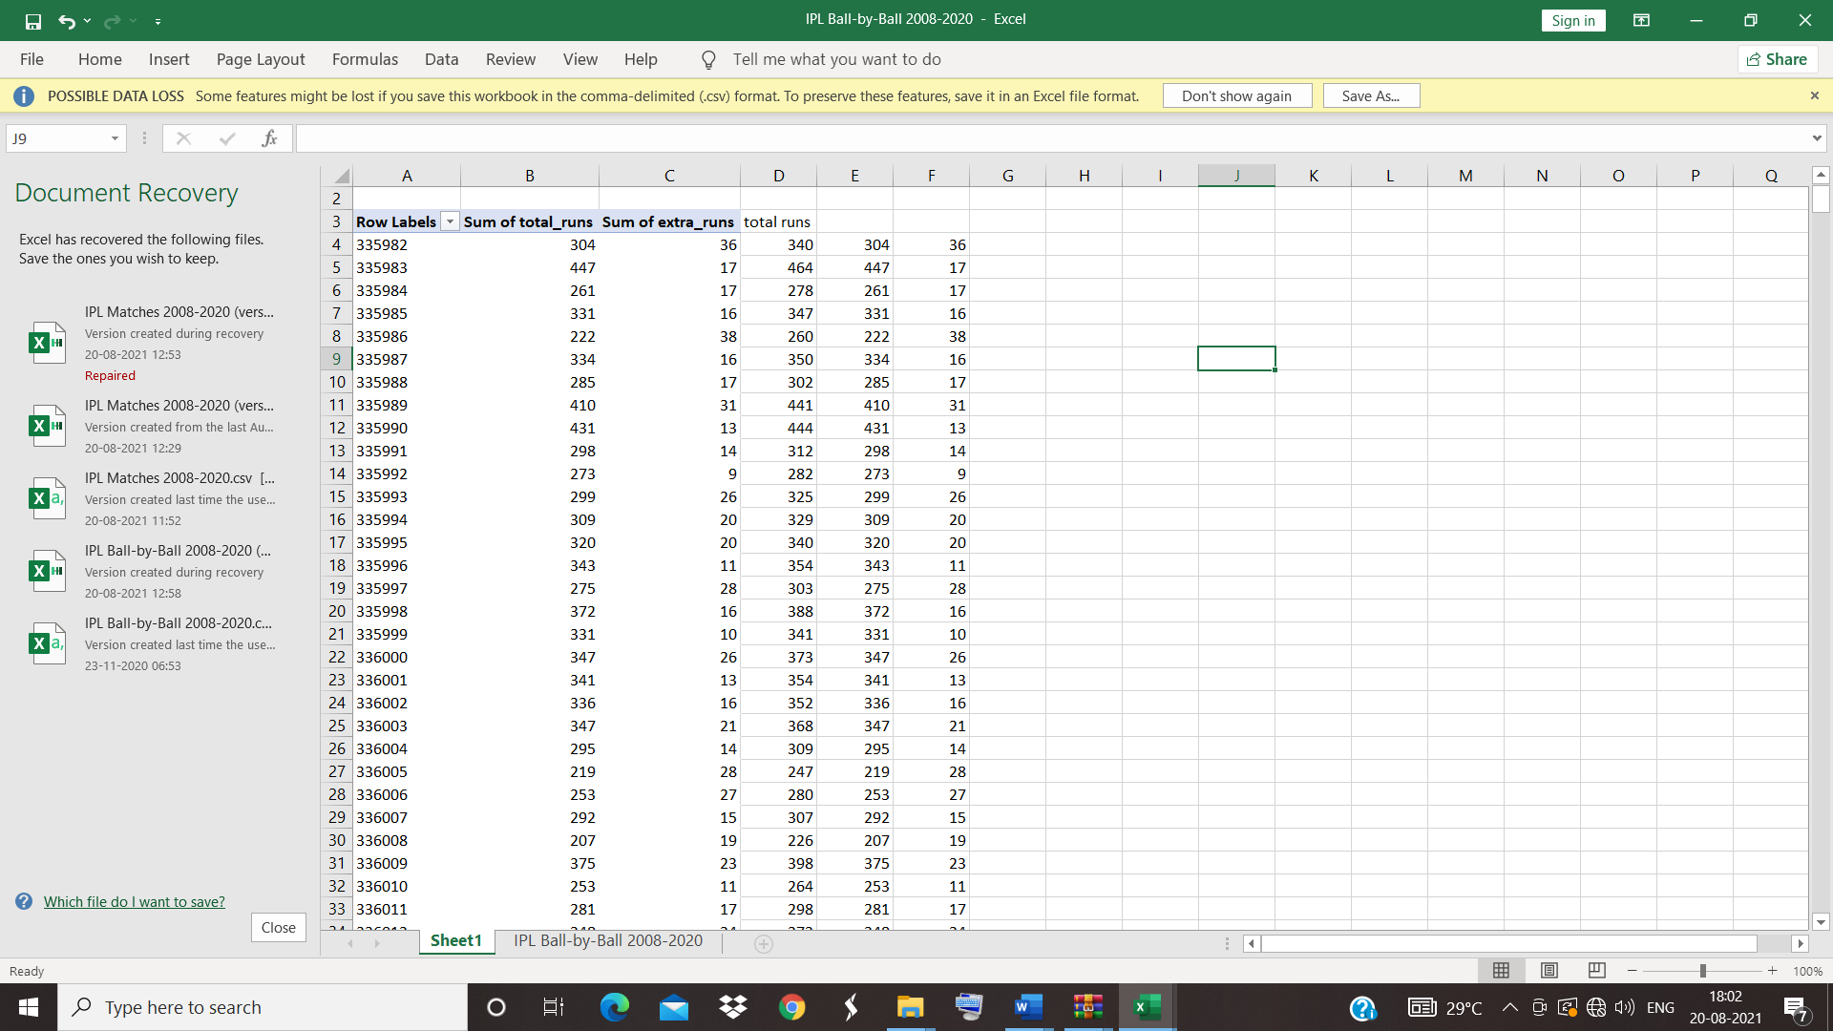

* Open file ‘ IPL matches 2008 -2020’ >>select date column>> select data tab >> text to columns >> delimited >> type ‘-‘ in special charcter >>

Then date , month and year columns are formed

* Copy total runs from ipl ball -by ball -2008-2020
* Create pivot table>> drag **year** to axis and **sum of total runs** in values >> pivot chart is also created.

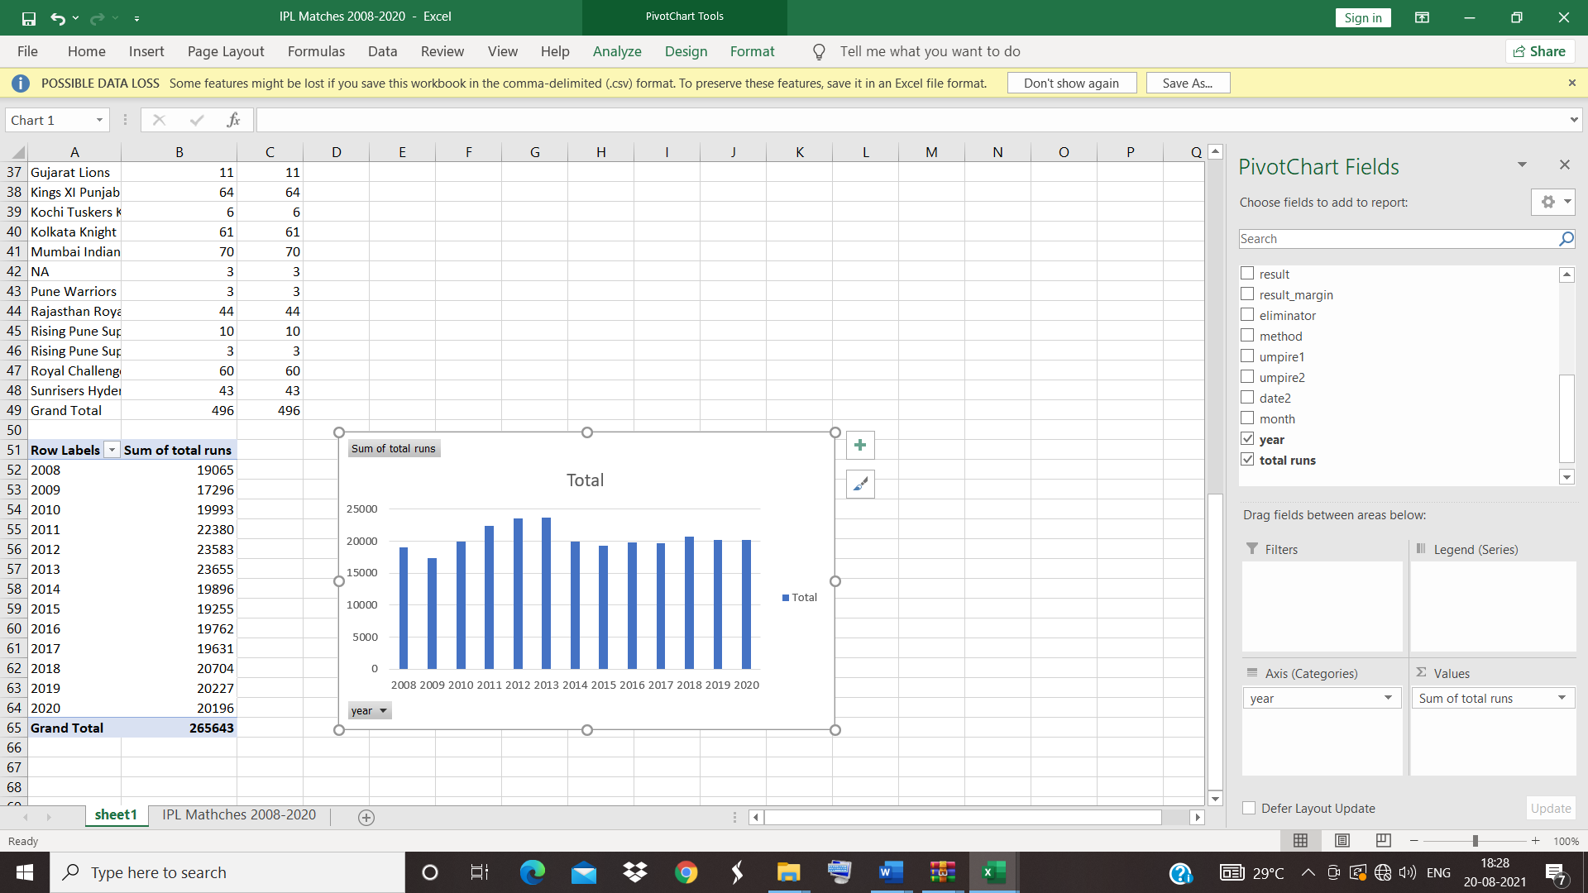

From this pivot table and chart runs scored in each season can be find.

Eg. In 2013,, 23655 runs is scored.

**5.** [**What were the runs scored per match in different seasons?**](https://www.kaggle.com/saiswaroop018/ipl-data-analysis-and-visualization-project#3)

* Open file ‘ IPL ball- by -ball 2008 -2020’>> create pivot table>> drag **ID** in to rows and drag **Sum of total_runs** and **Sum of extra_runs**  in to values .Total runs is created by summing total and extra runs.



Eg. Match id -335982 ( Royal challengers Vs Kolkata knight riders ) runs scored is 340( total runs is 304 and extra runs 36 ) .

**6.** [**Who has umpired the most?**](https://www.kaggle.com/saiswaroop018/ipl-data-analysis-and-visualization-project#4)

Create pivot table >>umpire 1 as rows and count of umpire 1 as values.

Pivot table and chart is created.

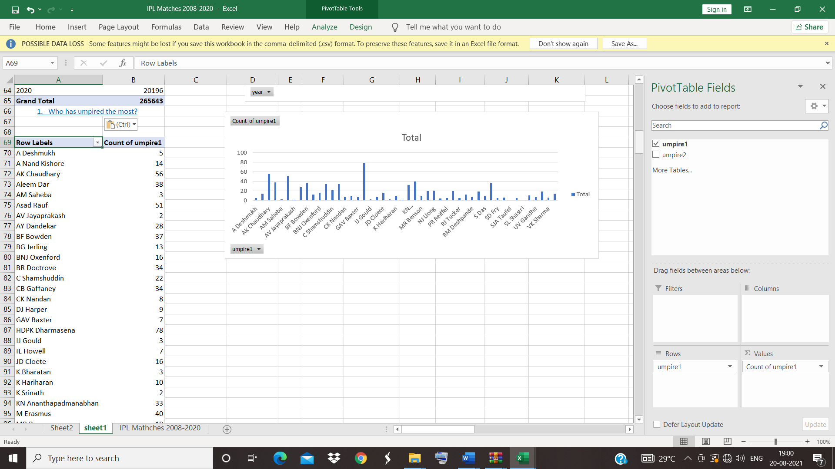

HDPK Dharmasena umpire most as 1 st umpire.

**7.   Which team has won the most tosses?**

* Create pivot table>>toss winner as rows and count of toss winner as values>>

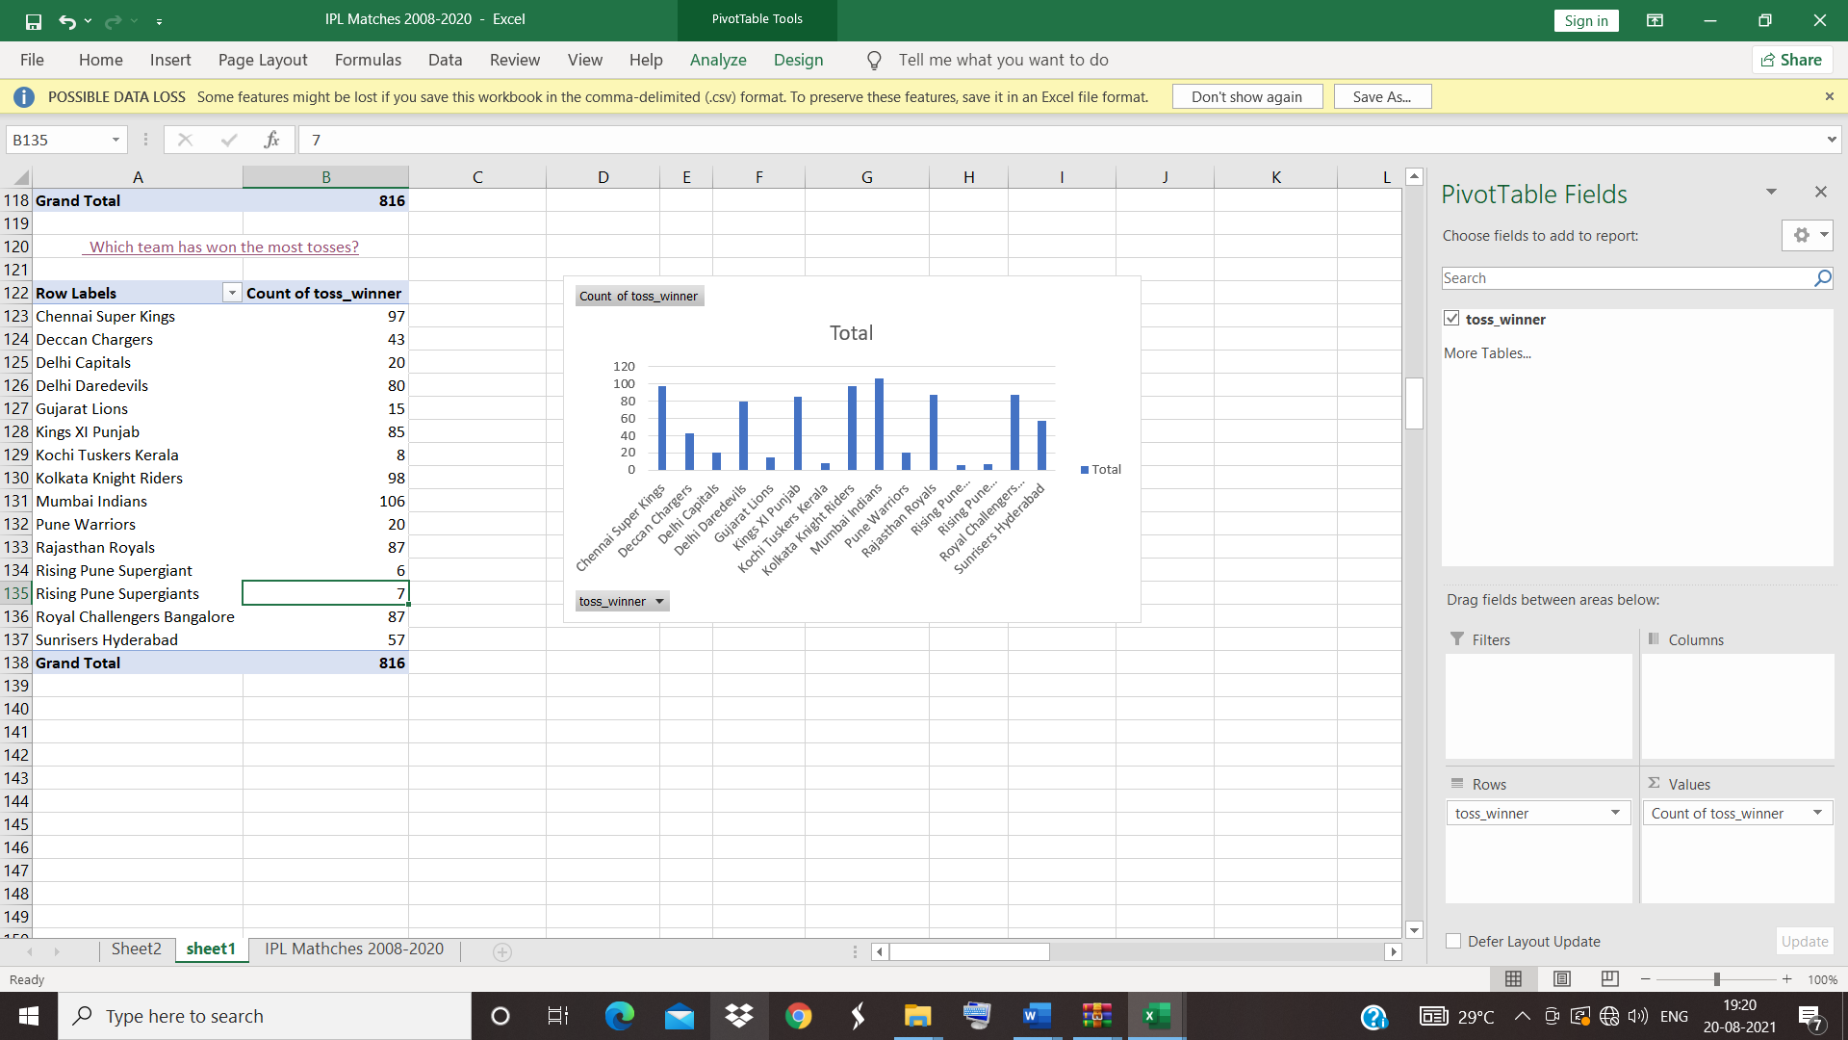

Mumbai Indians wins the toss most of times.

**8.** [**What does the team decide after winning the toss?**](https://www.kaggle.com/saiswaroop018/ipl-data-analysis-and-visualization-project#6)

* Create pivot table>>toss decision as rows and count of field as values

Pivot table and chart is created

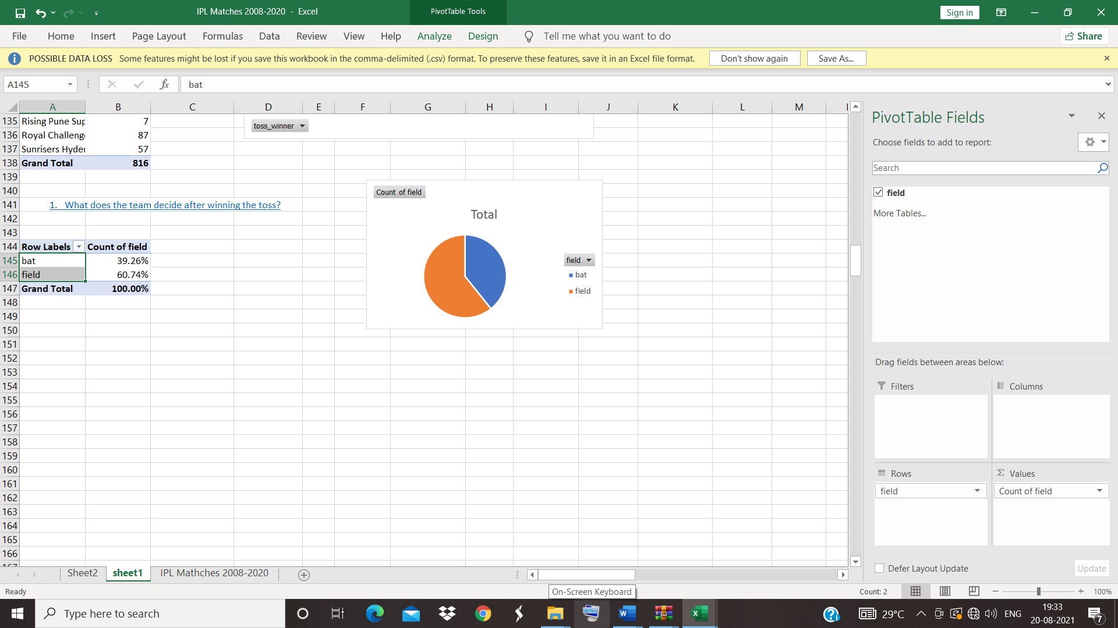

After winning the toss, team decides to field most.

**9.** [**How toss decision varies across seasons?**](https://www.kaggle.com/saiswaroop018/ipl-data-analysis-and-visualization-project#7)

Create pivot table>>toss decision as rows >> columns as years>> values as count of toss decision>> insert slicer toss decision is selected

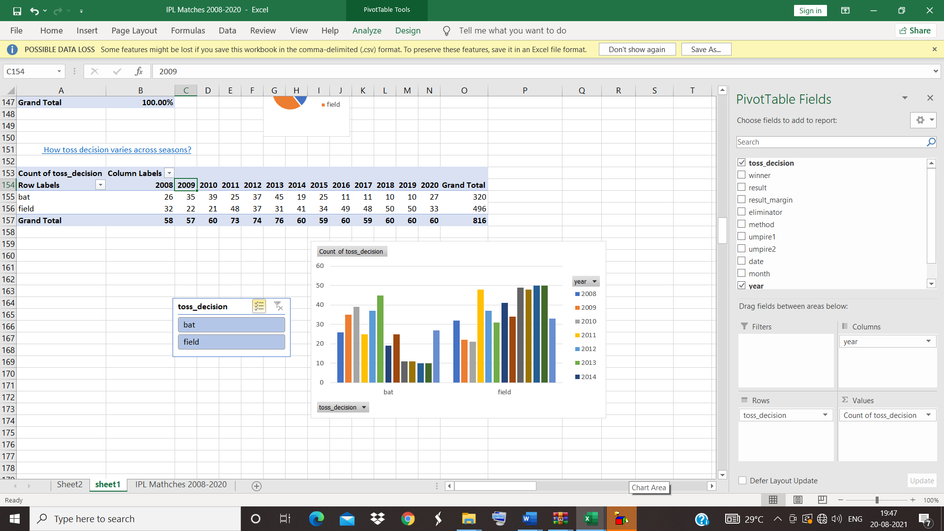

From the year 2008to 2020 toss decision to field is preferred than to bat.

**10.    Does winning the toss implies winning the game?**

* Toss winner and winner columns are selected.
* A new column is added with an equation of toss winner = winner , if both are equal then result is true ,other wise false.
* Pivot chart is created with this new column and a pie chart is created.

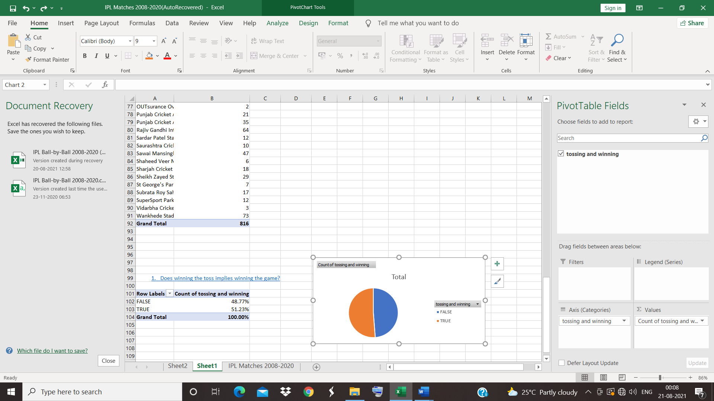

51.23 % of toss winner wins the match and 48.77% fails the match.

So, the probability of wins a match by winning the toss is almost equal to 0.5

**11.** [**Which team has played the most number of matches?**](https://www.kaggle.com/saiswaroop018/ipl-data-analysis-and-visualization-project#11)

A column of team is made by clubbing team 1 and team 2 and pivot table is created with team on axis and count of team as values. Pivot chart is also created

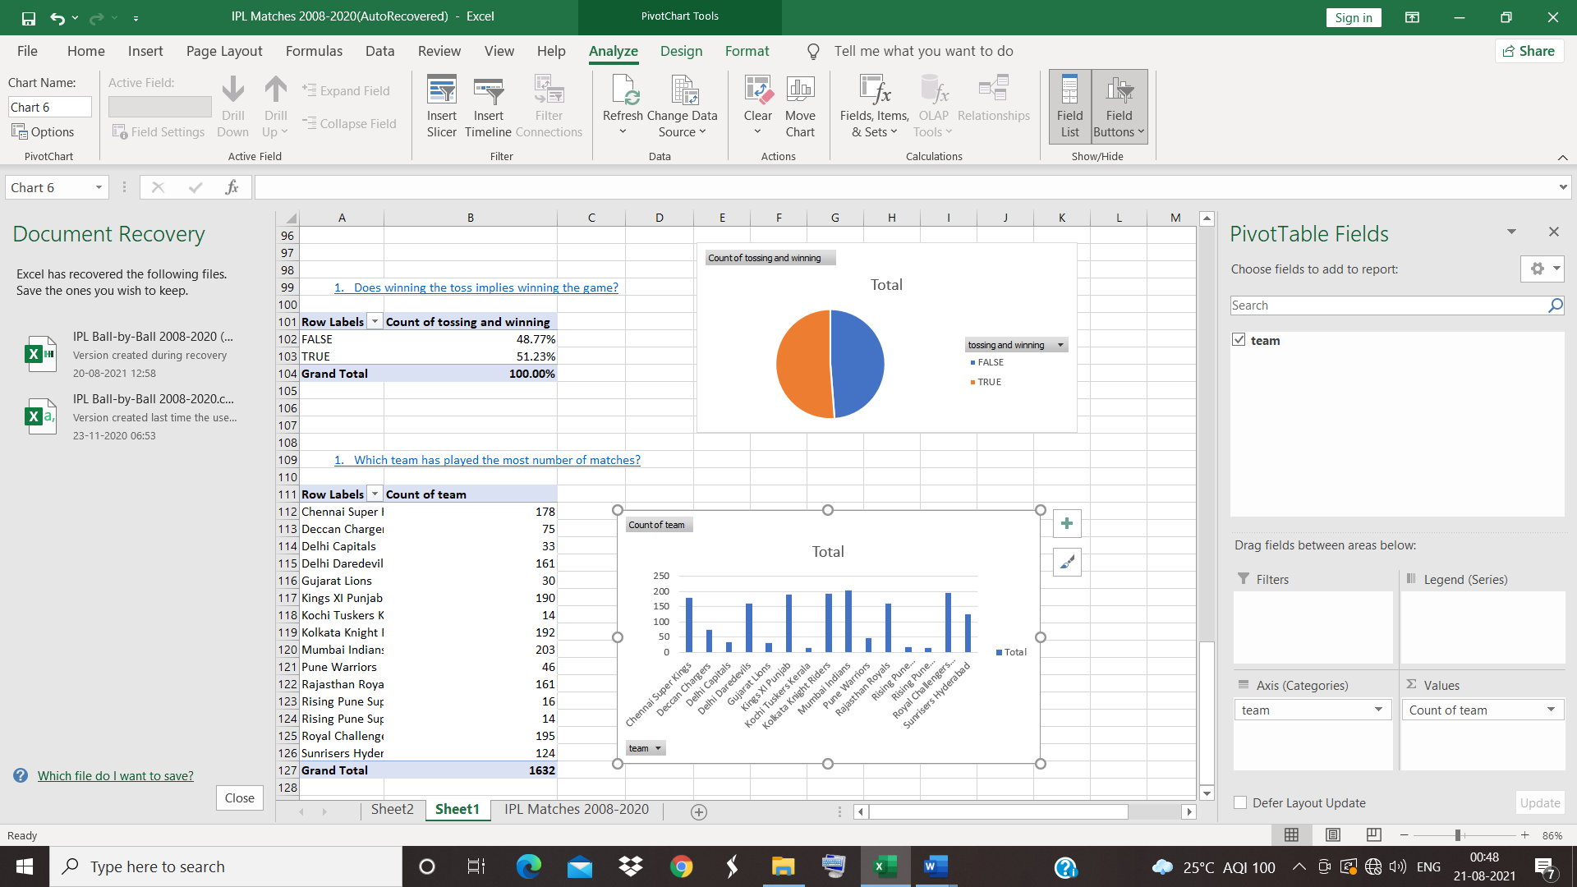

Mumbai Indians played most of the matches followed by Chennai super kings

**12.** [**Is there any lucky venue for a particular team?**](https://www.kaggle.com/saiswaroop018/ipl-data-analysis-and-visualization-project#14)

Venue column and winner is selected. Venue is dragged to axis ,winner in legend and count of winner as values. pivot table is created.

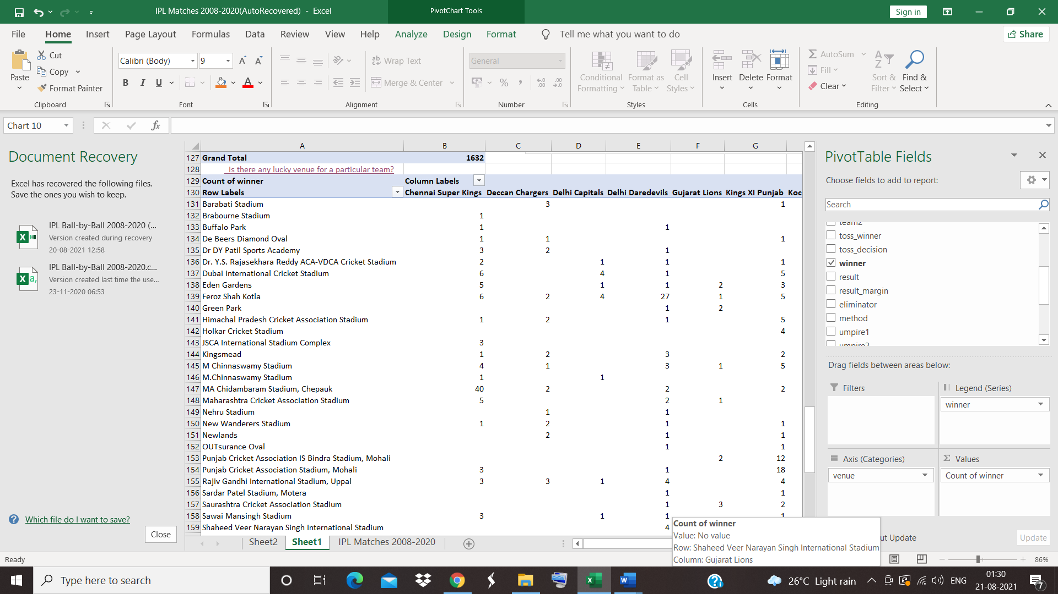

Piechart is created

Chennai superkings wins 40 matches in MA Chidambaram Stadium, Chepauk located in Chennai.

Also , Kolkata knight riders wins 45 matches in Eden garden located in Kolkata.

It can concluded that team won most of matches in their hometown.

**13.** [**Comparison between two teams**](https://www.kaggle.com/saiswaroop018/ipl-data-analysis-and-visualization-project#15)

Pivot chart is created with winner in axis ,years in legend and count of winner as values. Slicer is created using insert slicer.( to select two teams)

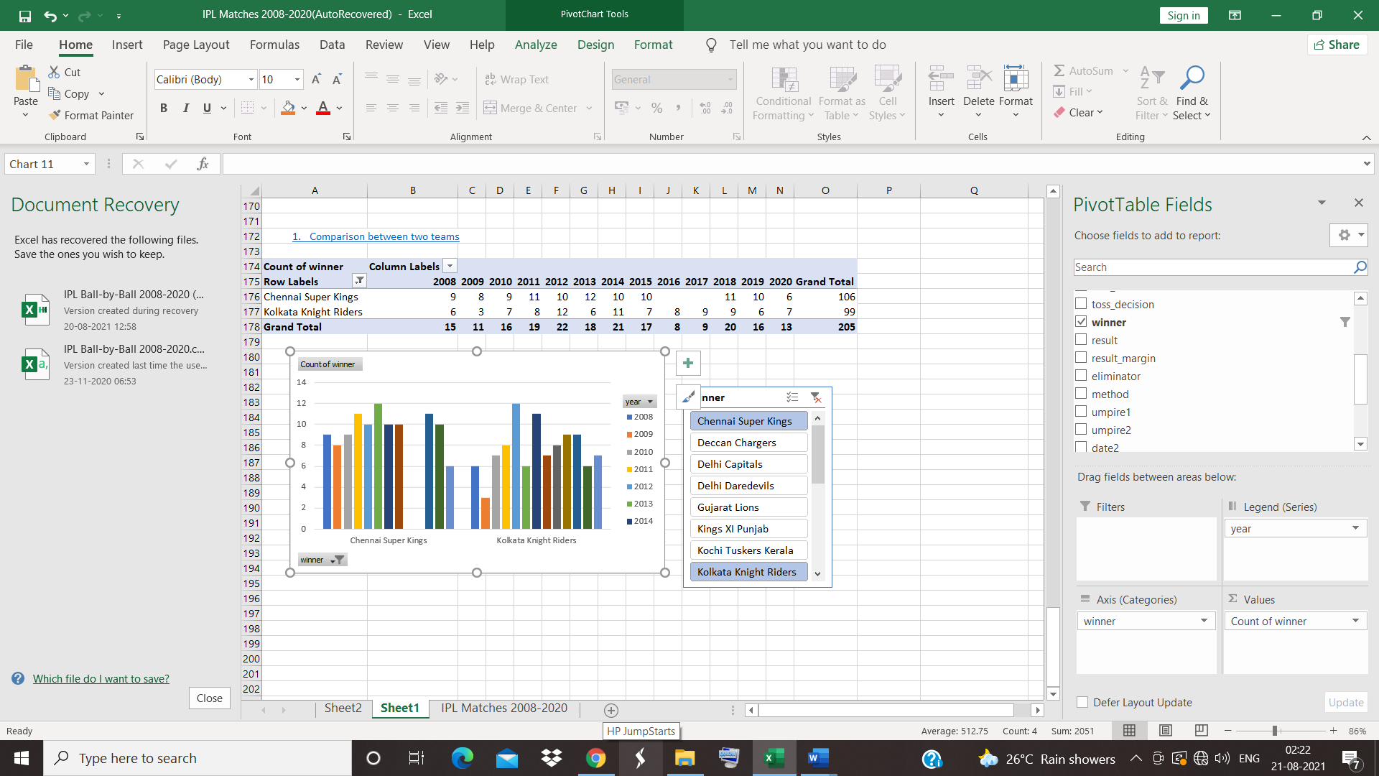

Here, chennai super kings and Kolkata knight riders are selected for the comparison.in the year 2013there is much difference between (6) the winning , Chennai superkings wins 12 times ,where as Kolkata knight riders wins only 6 times.

**14.** [**Particular Batsmen analysis**](https://www.kaggle.com/saiswaroop018/ipl-data-analysis-and-visualization-project#16)

Pivot table is created using batsman in rows and sum of batsmen as values.

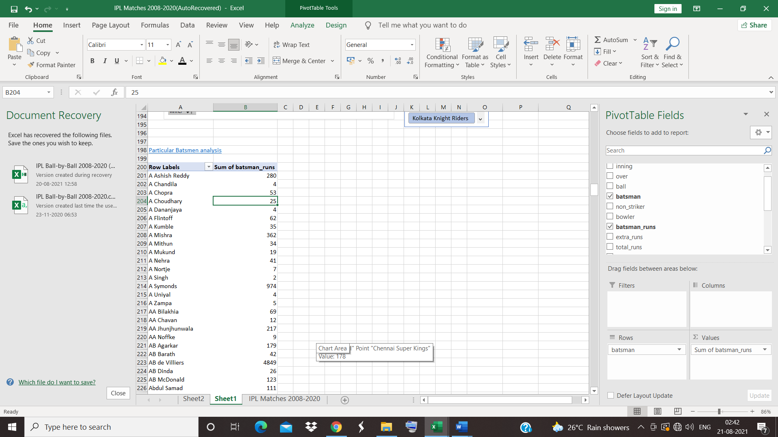

Out of which, virat kohli scores 5878 runs.

The performance of v.kohli is analysed using pivot table and slicer

He has taken a count of 692 ,two’s ,39 three’s, 2016 four’s, 1212 sixes.

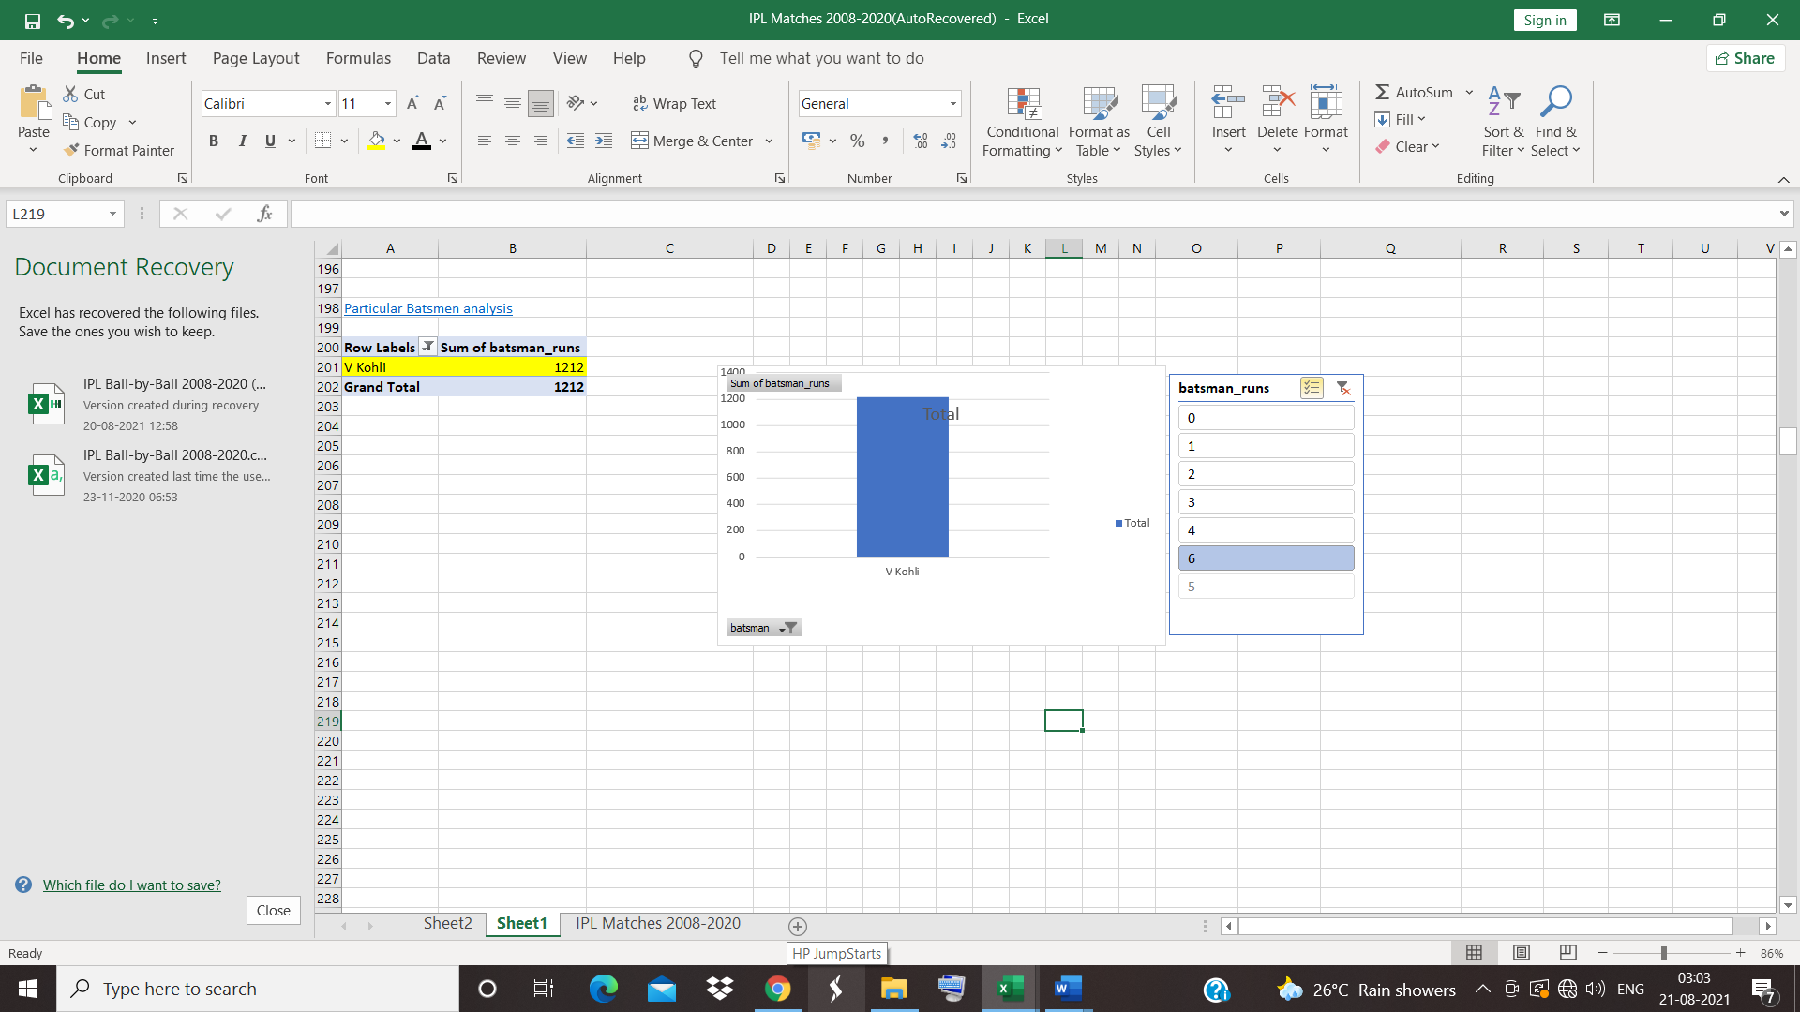 He Has scored more runs by taking sixes.

**IPL DASHBOARD CREATION**

Create pivot table>> winner as rows >> values as count of winner>> insert slicer ,team 1,team 2 ,result is selected.

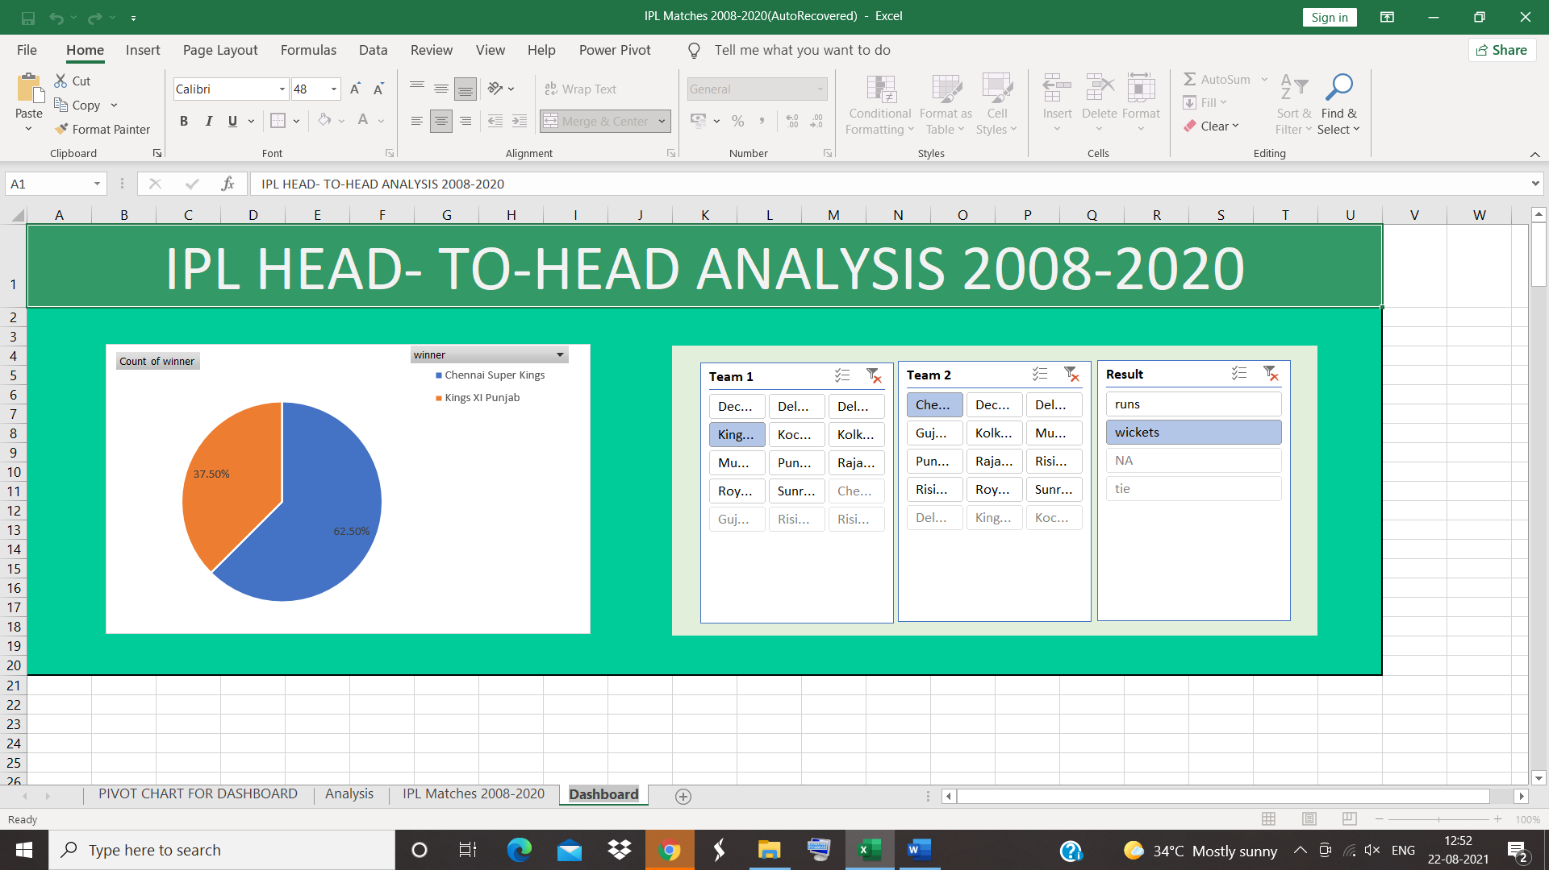

Inference

* Kings 11 Punjab has more tie match
* Most won team by batting first is Mumbai Indians.
* Most won team by batting second is Mumbai Indians.
* Mumbai Indians was beaten by Rajasthan royals and Chennai super kings most.
* Chennai super kings was beaten by Mumbai Indians most.